Teaching and Learning Policy 2025-27

Our mission statement: Learn Love Laugh

Safeguarding
If there are any Safeguarding issues that arise from the implementation of this policy, then they should be dealt with in accordance with the School's Safeguarding policy. Any safeguarding concerns should be referred directly to the School by telephone or in person for the attention of the Designated Safeguarding Lead along with any concerns relating to the Prevent Strategy.

Equality
This policy should be read in conjunction with the School’s Equality Policy. The general equality duty requires that, in the exercise of their functions, schools must have due regard to the need to eliminate unlawful discrimination, harassment, victimisation and other conduct prohibited by the Equality Act 2010. This school endeavours to advance equality of opportunity and foster good relations for all.

When reviewing/In approving this policy, you are confirming that the policy raises no equality issues by having an impact that may disadvantage one or more of the target groups below:
Age (N/A to school children) | Marriage & Civil Partnership | Religion, Faith and belief
Disability | Pregnancy & Maternity | Sex
Gender Assignment | Race | Sexual Orientation

Vision Statement

Together we build a community in which EVERYONE is:
- safe, included and respected (We Love)
- inspired, equipped and achieving (We Learn)
- celebrated, confident and thriving (We Laugh)

Aims

At our school we provide a purposeful, calm learning environment that allows children to develop their skills and abilities to their full potential – our pedagogy and approaches are informed by research and proven impact. Our aim is that teachers deliver our intended and agreed school curriculum – overseen by Senior Leaders and Subject Leads – and as such children learn intentionally, progressively and logically.

Our curriculum intention is to provide children with the opportunities to:

- Learn to value themselves and others, their views, cultures and beliefs
- Acquire knowledge that will underpin their understanding throughout the curriculum
- Celebrate the uniqueness of everyone, treating everyone with care and respect
- Develop a range of skills to support life-long learning
- Communicate and interact effectively with others
- Listen and empathise
- Make a positive contribution to the school, local and wider community
- Enjoy the challenge of learning in a variety of ways, making full use of the indoor and outdoor environment and the wider locality
- Become reflective learners who have a sense of responsibility for their own learning and development
- Know the importance of achieving their best

Root Christian Values in the curriculum

Our root Christian value of Love (enacted through a developing understanding of relating to each other through kindness → compassion, gentleness → humility and
patience → forgiveness). These underpin everything we do and expect in our school community. There are many opportunities to unpack these values in curriculum subjects; even beyond RE, PSHCE and Collective Worship, and teachers plan this half termly and detail ideas/links in medium term planning.

Our Agreed Teaching Principles (The Sandford Way) these are indicative of consistent daily practice in teaching and learning, not a checklist for every lesson

The I do / we do / you do approach (see appendix 2 for visual representation)

I do:
- Establish purpose:. Share intended outcomes. Link learning to previous (and future) learning.
- Explain content clearly: Teach the new content, breaking it into small steps. Use visual representation, allowing thinking and processing time. Use simple diagrams. Use manipulatives. Avoid using speech and text: children cannot listen and read simultaneously.
- Ensure all children are paying attention. Expect all children to be watching and listening. Reduce cognitive load (e.g. overly-busy displays and screens). Use ‘active’ engagement strategies.
- Model: Walk through the process to show children an example. Repeat. Teach in small steps to reduce cognitive load. Provide ambitious high-quality examples. Use correct, subject-specific vocabulary.
- Think aloud: Model the process whilst thinking aloud (e.g. model choosing specific vocabulary to have a particular effect).
- Give explicit instructions. Pick your spot. Face the children and stand still. Formal tone. Economy of language. Check for understanding.
We do:
Dynamic, responsive teaching is the key to high quality teaching and learning. The feedback loop should be live ‘in lesson’ so the teacher regularly gleans the level of understanding in the children - by the children showing what they can and can’t do. Teaching is adapted within this dynamic loop.

- Interactive instruction: Provide scaffolded examples for children to complete. Prompt and support guided tasks. Use talk partners to support language development, providing sentence stems (e.g. I think… because…)
- Check for understanding: Teacher asks questions using a variety of: Cold-calling. No opt out. Use mini whiteboards to ensure participation from ALL children. Use focus children (low/middle/higher attainers). Choral responses (call and response). Think, pair and share. Ask open-ended questions: what have you understood?
- Develop pupils’ responses: use universal prompts such as: Tell me more? What makes you think that? How do you know? Why is that important? Provide sentence stems, e.g. ‘I know… because…’ ‘I think that… because…’
- Provide additional modelling or clarification: establish how confident pupils are. Return to the ‘I do’ phase if necessary and provide further modelling.
- Children ask questions: provide opportunities for children to ask questions.
- Decide when to move on: establish whether pupils are ready to move into the independent phase.
You do:
- Provide success criteria: provide success criteria so pupils know how to be successful.
- Set expectations: TORN (Time / Outcome / Resources / Noise level). For example, ‘You have 15 minutes to write four sentences in the front of your book. We are going to complete this in silence so that everyone can focus.’ Check in with the children, ‘How long do we have?’ ‘How many paragraphs do you need to write?’
- Struggle/grapple time: Allow struggle/grapple time so children have an opportunity to apply independent learning skills.
- Ensure all children are on task: narrate the positive, ‘I like how Phil has made a quick start,’ or, ‘Fantastic handwriting from Paul, what a great start!’ Deliberately scan the room (Be seen looking) for off-task behaviour. Anticipate off-task behaviour. Redirect children with the least invasive intervention necessary, e.g. proximity, eye contact, non-verbal, recall previous positive or natural consequences.
- Provide scaffolding. Provide scaffolding to allow all children to access the learning. Link this to prior attainment, interventions and SEND profiles. Provide teacher and TA led focus groups based on the children’s need for support or more focused teaching in the lesson.
- Monitor children’s progress vigorously: circulate the room and know what you’re looking for. For example, checking that all children’s handwriting on their first sentence is neat, or checking that all children have applied the correct method in maths. Carry out live marking. Provide 1:1, small group or whole class feedback. Use mini-plenaries; not being afraid to move back to whole-class teaching.
- Re-visit success criteria and learning aims regularly: support children to peer and self-assess their own and others’ work. Use praise, live feedback and good models/examples in high prevalence to promote clear understanding

EYFS and wider play principles

Most studies suggest that high-quality provision includes both play and adult-directed activities, and minimises time spent on classroom management. In child initiated learning we recognise the vital role of the adult in supporting, guiding and extending the learning. This is true for pupils with high needs and their provision/support is weighted in this way too.

Consistency and monitoring

Teachers use their experience and professional judgement when designing and implementing teaching and learning structures. Our agreed features of effective teaching and learning are monitored and evaluated within ongoing performance indicators/lesson observations and book monitoring. School agreed planning frameworks provide a focus for teaching staff to ensure key lesson elements are considered in advance.

The Governing Body, Headteacher and Senior Leaders have a responsibility to ensure this policy is evident in practice. Descriptions of effective teaching and learning in this policy are used in the monitoring process through a range of activities such as drop ins, formal lesson observations, work scrutiny, planning scrutiny, analysing assessments, talking with children and staff and looking at the impact of feedback/marking.

Appendix 1
Growth mindset

We believe a ‘growth mindset’ is fundamental in unlocking the best teaching and learning. It is only with a growth mindset that true learning can happen at the deepest and richest levels.

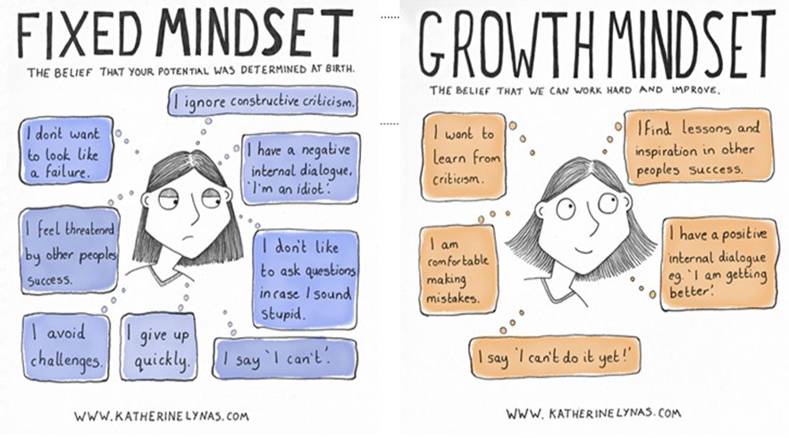
Appendix 2
I do, We do, You do
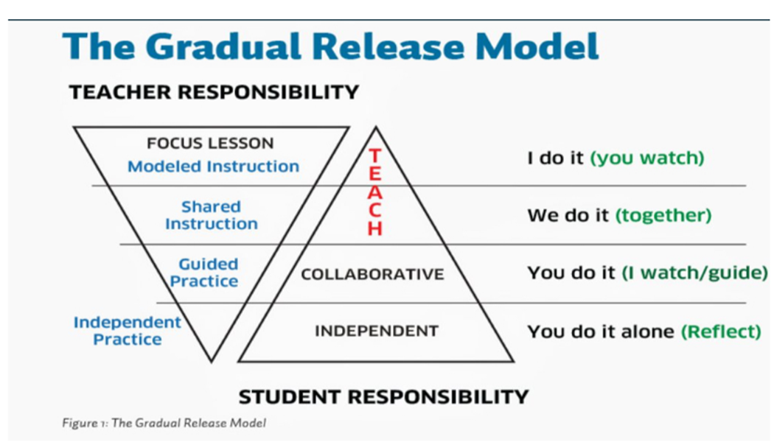

 SANDFORD ST MARTIN’S CE (VA) PRIMARY SCHOOL

TEACHING AND LEARNING POLICY

Date adopted: 30th March 2023 | Version: 2.0
Last Reviewed: March 2023 | Review Cycle: Every two years
Revision Ref: | 29th March 2025
Author/Owner: | Headteachers/Standards & Assessment Committee
Policy Type: | Curriculum

